Counting
# Source: AI Source: Provided by: [Data Path: Persons Table -> ID Column: 1, Name_En Column: Motasem Essam] -> From: [ChatGPT] on [7/11/2026]
Counting is the process of determining the number of objects in a collection by assigning one unique counting number to each object in a specific order. It is one of the most fundamental concepts in arithmetic and forms the basis for understanding numbers, addition, subtraction, and many other mathematical operations.
Counting begins with the natural numbers:
1,2,3,4,5,…
and continues indefinitely.

Definition
# Source: AI Source: Provided by: [Data Path: Persons Table -> ID Column: 1, Name_En Column: Motasem Essam] -> From: [ChatGPT] on [7/11/2026]
Counting is the process of assigning consecutive counting numbers to objects in a set to determine how many objects are present.
Each object is counted exactly once, and the last number spoken represents the total number of objects.

Principles of Counting
# Source: AI Source: Provided by: [Data Path: Persons Table -> ID Column: 1, Name_En Column: Motasem Essam] -> From: [ChatGPT] on [7/11/2026]
Effective counting follows these fundamental principles:

1. One-to-One Correspondence
# Source: AI Source: Provided by: [Data Path: Persons Table -> ID Column: 1, Name_En Column: Motasem Essam] -> From: [ChatGPT] on [7/11/2026]
Each object is assigned one and only one counting number.
Example:
🍎 🍎 🍎
Count:
- First apple → 1
- Second apple → 2
- Third apple → 3

2. Stable Order Principle
# Source: AI Source: Provided by: [Data Path: Persons Table -> ID Column: 1, Name_En Column: Motasem Essam] -> From: [ChatGPT] on [7/11/2026]
The counting numbers must always be used in the correct order.
1,2,3,4,5,…
not
1,3,2,5.

3. Cardinality Principle
# Source: AI Source: Provided by: [Data Path: Persons Table -> ID Column: 1, Name_En Column: Motasem Essam] -> From: [ChatGPT] on [7/11/2026]
The last counting number represents the total number of objects.
Example:
🍎 🍎 🍎 🍎
Count:
1, 2, 3, 4
There are 4 apples.

4. Order Irrelevance Principle
# Source: AI Source: Provided by: [Data Path: Persons Table -> ID Column: 1, Name_En Column: Motasem Essam] -> From: [ChatGPT] on [7/11/2026]
Objects may be counted in any order.
Example:
Whether you count
Left → Right
or
Right → Left,
the answer remains the same.

5. Abstraction Principle
# Source: AI Source: Provided by: [Data Path: Persons Table -> ID Column: 1, Name_En Column: Motasem Essam] -> From: [ChatGPT] on [7/11/2026]
Any collection of objects can be counted.
Examples:
- Books
- Cars
- Animals
- People
- Stars
- Ideas (in some contexts)

Types of Counting

1. Forward Counting
# Source: AI Source: Provided by: [Data Path: Persons Table -> ID Column: 1, Name_En Column: Motasem Essam] -> From: [ChatGPT] on [7/11/2026]
Counting from a smaller number to a larger number.
Example:
1,2,3,4,5,6,…

Definition
# Source: AI Source: Provided by: [Data Path: Persons Table -> ID Column: 1, Name_En Column: Motasem Essam] -> From: [ChatGPT] on [7/11/2026]
Forward Counting is the process of counting numbers in ascending order, starting from a given number and moving toward larger numbers according to a specified counting sequence or increment.
It is one of the fundamental counting skills in mathematics. It helps learners understand number order, recognize numerical patterns, determine the next number, and develop the foundation for addition, multiplication, and skip counting.
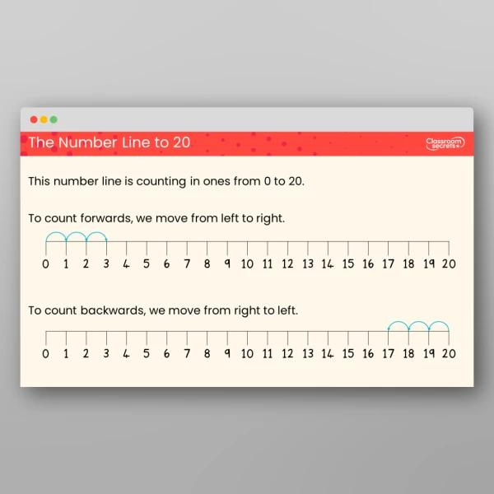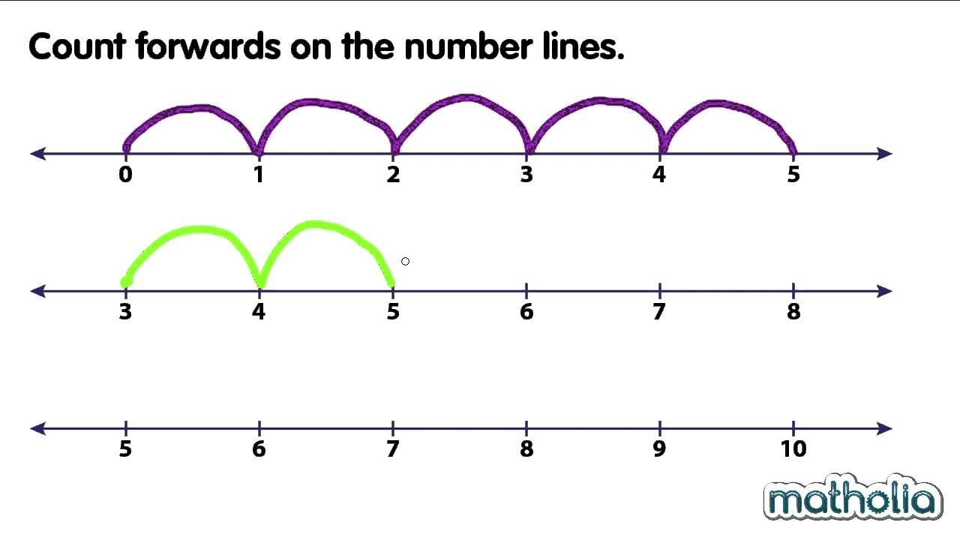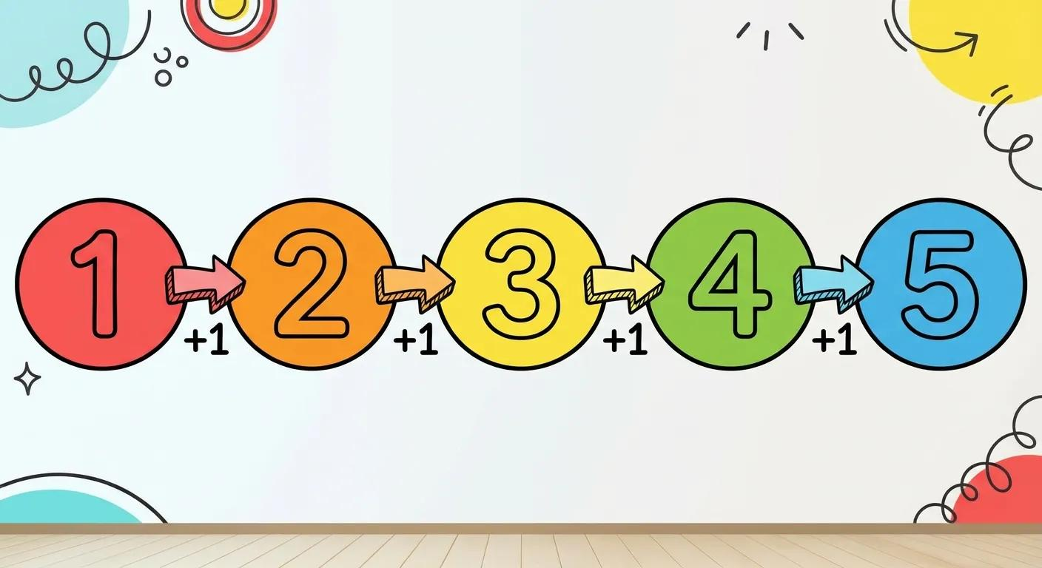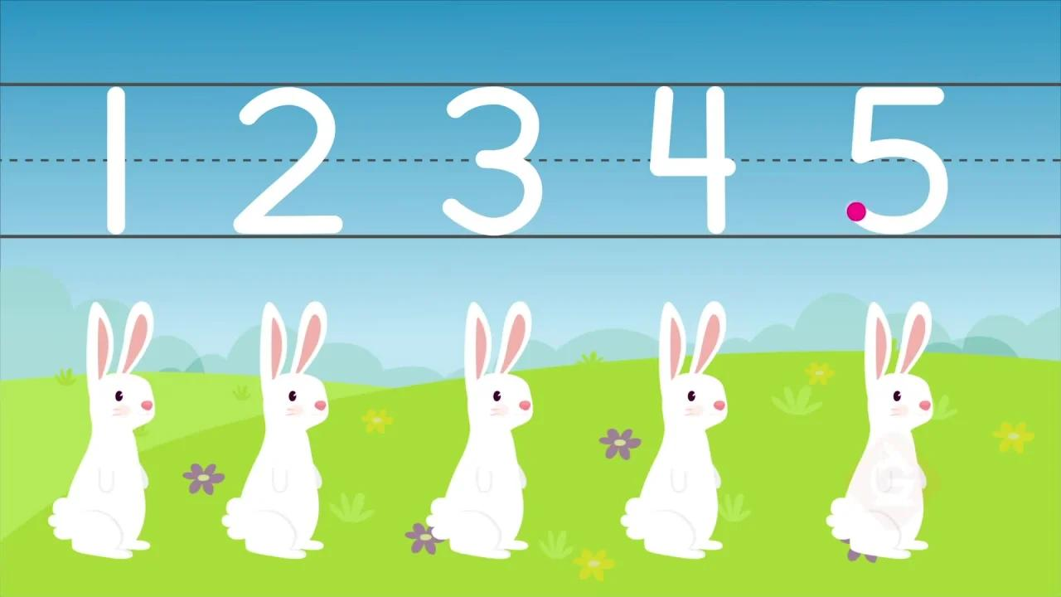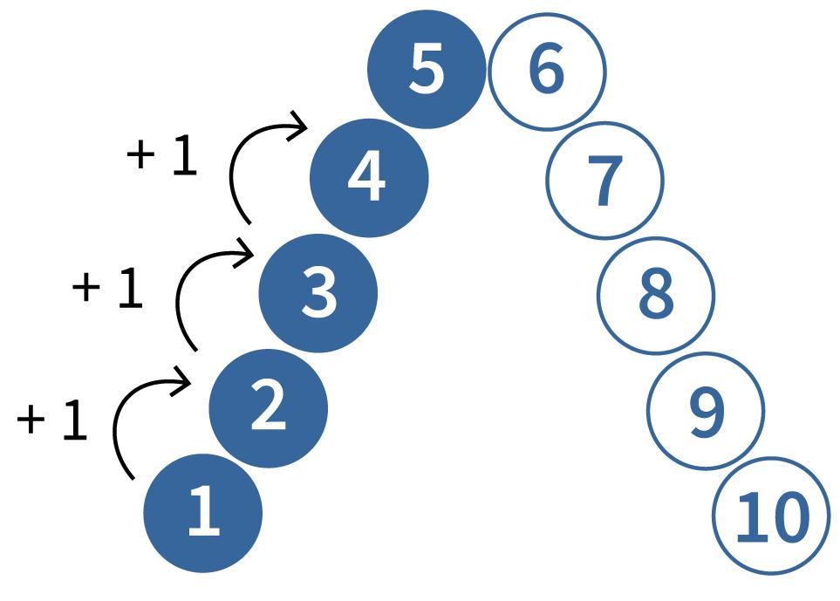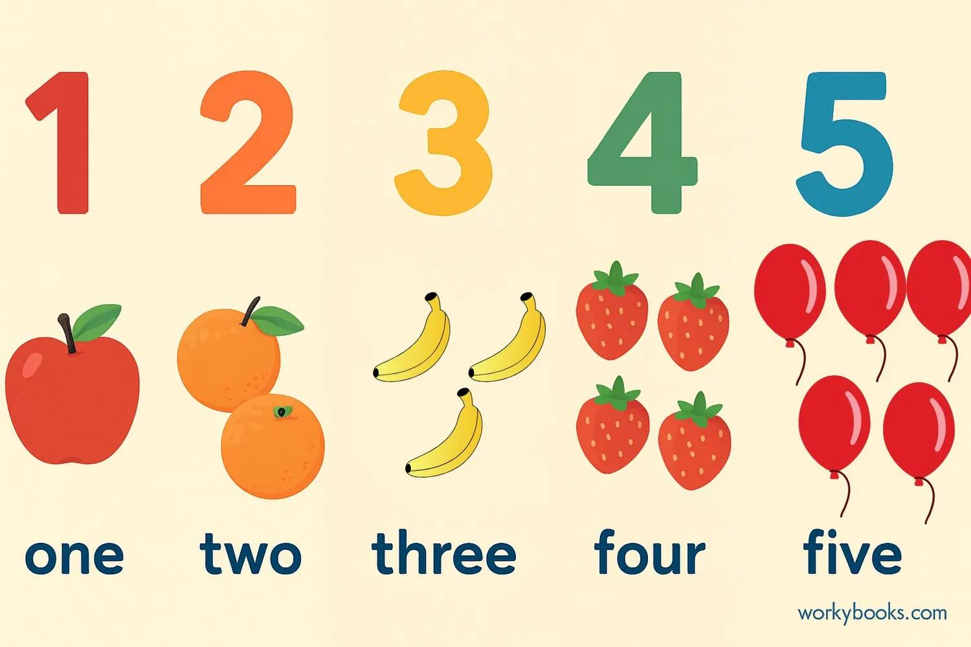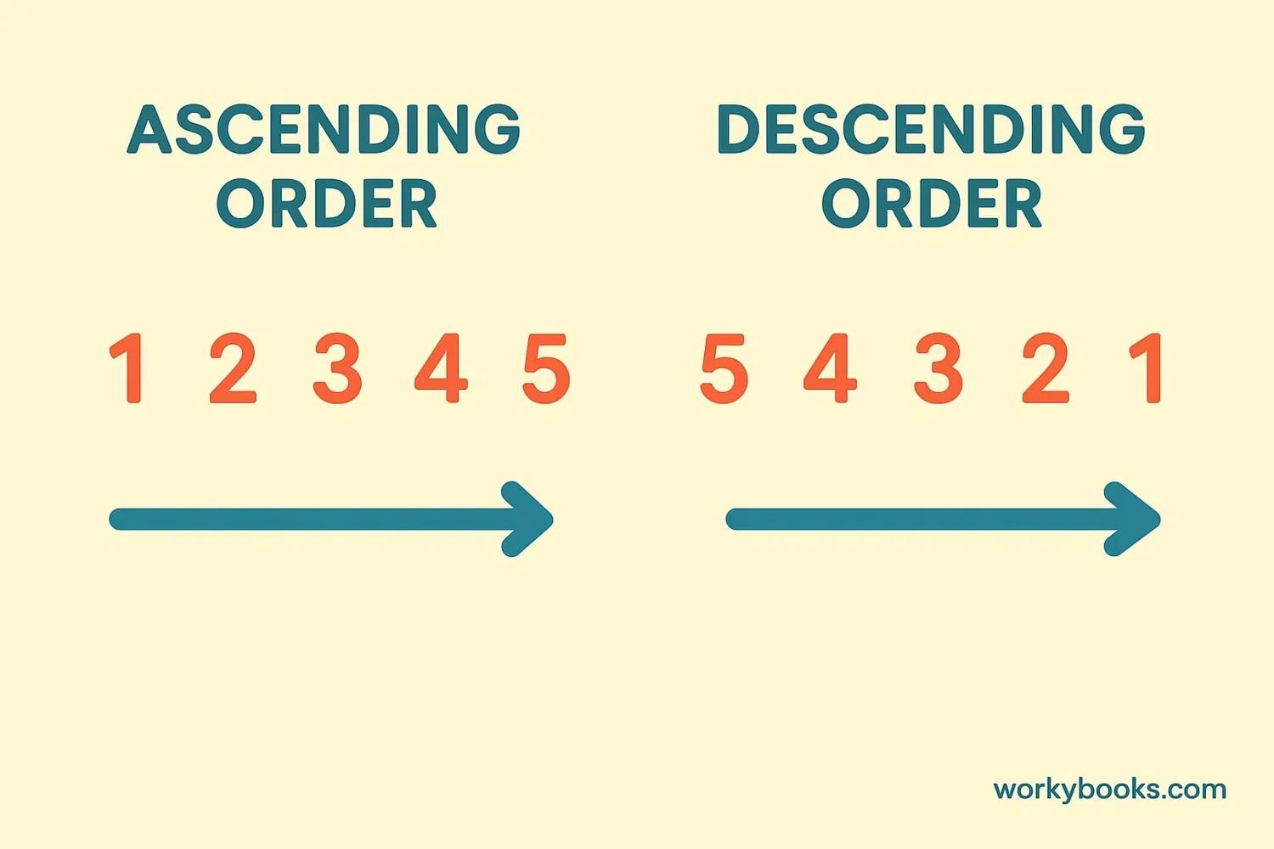

Simple Definition
# Source: AI Source: Provided by: [Data Path: Persons Table -> ID Column: 1, Name_En Column: Motasem Essam] -> From: [ChatGPT] on [7/11/2026]
Forward counting means saying or writing numbers from a smaller number to a larger number in the correct order.
Example:
1, 2, 3, 4, 5, 6, 7, 8, 9, 10
Each number is greater than the number immediately before it.

Main Characteristics
# Source: AI Source: Provided by: [Data Path: Persons Table -> ID Column: 1, Name_En Column: Motasem Essam] -> From: [ChatGPT] on [7/11/2026]
- Ascending Order: Numbers increase as counting progresses.
- Starting Number: Counting can begin at 1, 0, or any other specified number.
- Counting Direction: The sequence moves toward larger numbers.
- Consistent Progression: Each next number follows the specified counting interval.
- Number Recognition: It strengthens recognition and understanding of numerical order.
- Pattern Recognition: It helps learners identify regular numerical sequences.
- Addition Foundation: It supports understanding addition as moving forward along a number line.

Types of Forward Counting

Forward Counting by Ones
# Source: AI Source: Provided by: [Data Path: Persons Table -> ID Column: 1, Name_En Column: Motasem Essam] -> From: [ChatGPT] on [7/11/2026]
Counting by ones means increasing the current number by exactly one each time.
Example:
1, 2, 3, 4, 5, 6, 7, 8, 9, 10
Starting from 6:
6, 7, 8, 9, 10, 11, 12
Key Point: Each next number is obtained by adding 1.

Forward Counting by Twos
# Source: AI Source: Provided by: [Data Path: Persons Table -> ID Column: 1, Name_En Column: Motasem Essam] -> From: [ChatGPT] on [7/11/2026]
Counting by twos means increasing the current number by 2 each time.
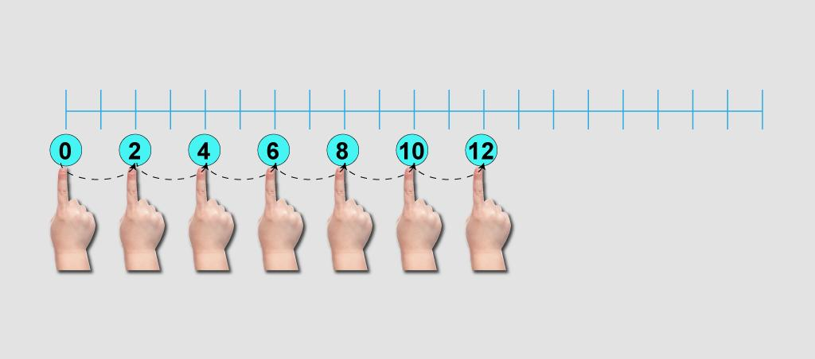
Example:
2, 4, 6, 8, 10, 12, 14, 16, 18, 20
Starting from 5:
5, 7, 9, 11, 13, 15
Key Point: Each next number is obtained by adding 2.

Forward Counting by Threes
# Source: AI Source: Provided by: [Data Path: Persons Table -> ID Column: 1, Name_En Column: Motasem Essam] -> From: [ChatGPT] on [7/11/2026]
Counting by threes means increasing the current number by 3 each time.
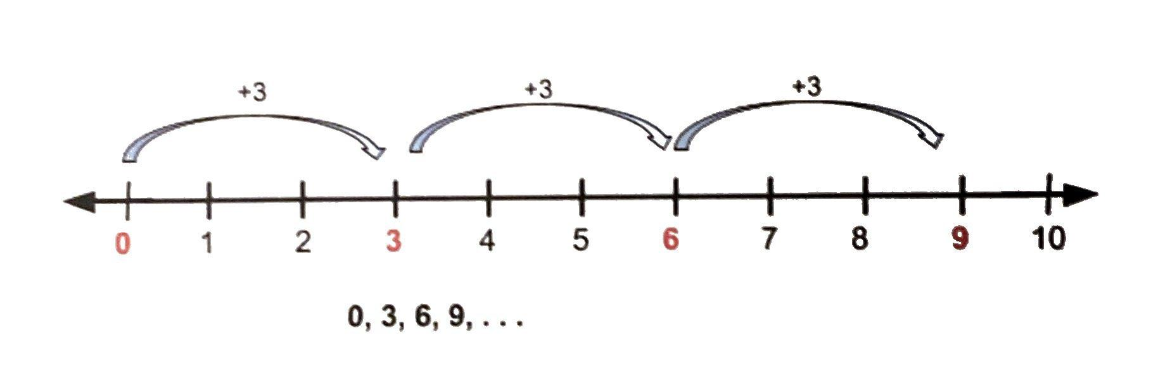
Example:
3, 6, 9, 12, 15, 18, 21, 24, 27, 30
Starting from 4:
4, 7, 10, 13, 16, 19
Key Point: Each next number is obtained by adding 3.

Forward Counting by Fives
# Source: AI Source: Provided by: [Data Path: Persons Table -> ID Column: 1, Name_En Column: Motasem Essam] -> From: [ChatGPT] on [7/11/2026]
Counting by fives means increasing the current number by 5 each time.
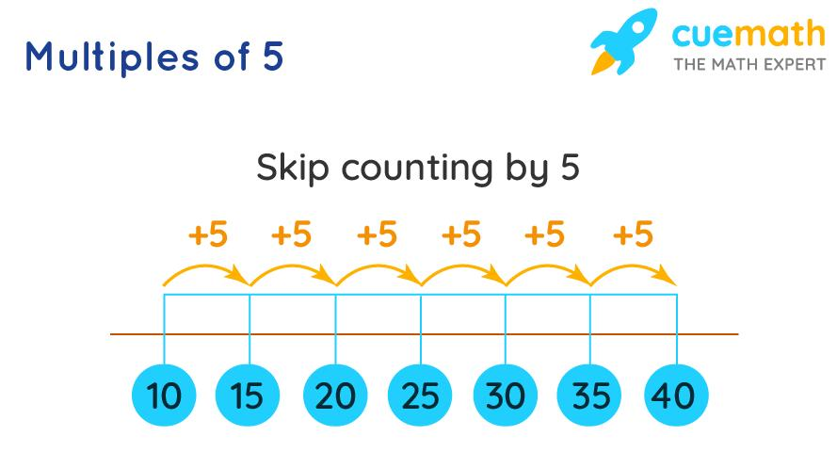
Example:
5, 10, 15, 20, 25, 30, 35, 40, 45, 50
Starting from 10:
10, 15, 20, 25, 30, 35
Key Point: Each next number is obtained by adding 5.

Forward Counting by Tens
# Source: AI Source: Provided by: [Data Path: Persons Table -> ID Column: 1, Name_En Column: Motasem Essam] -> From: [ChatGPT] on [7/11/2026]
Counting by tens means increasing the current number by 10 each time.
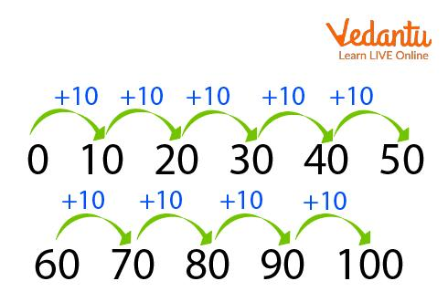
Example:
10, 20, 30, 40, 50, 60, 70, 80, 90, 100
Starting from 25:
25, 35, 45, 55, 65, 75
Key Point: Each next number is obtained by adding 10.

Forward Counting from a Given Number
# Source: AI Source: Provided by: [Data Path: Persons Table -> ID Column: 1, Name_En Column: Motasem Essam] -> From: [ChatGPT] on [7/11/2026]
This type begins with a specified starting number rather than necessarily beginning at 1 or 0. Counting then continues in ascending order using the selected interval.
Example:
Starting from 7 and counting by ones:
7, 8, 9, 10, 11, 12
Starting from 12 and counting by twos:
12, 14, 16, 18, 20, 22
Key Point: The starting number can change without changing the forward direction.

Forward Counting Across Tens
# Source: AI Source: Provided by: [Data Path: Persons Table -> ID Column: 1, Name_En Column: Motasem Essam] -> From: [ChatGPT] on [7/11/2026]
This type focuses on continuing the counting sequence when moving from one group of ten to the next.
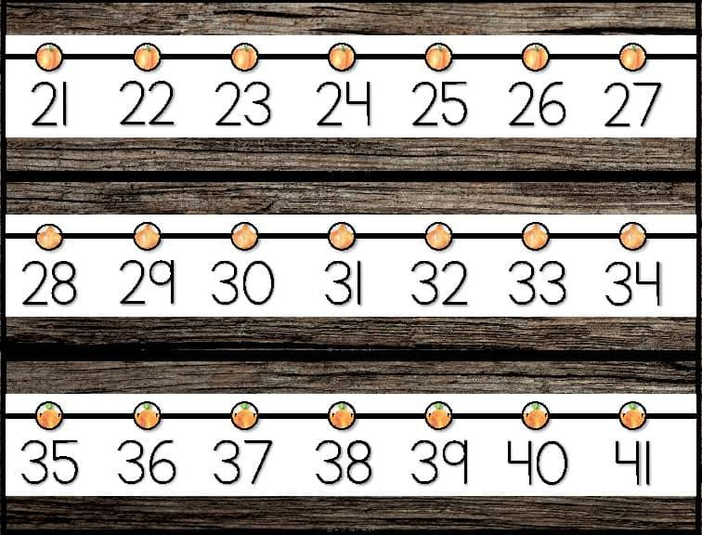
Example:
27, 28, 29, 30, 31, 32
Another example:
38, 39, 40, 41, 42, 43
Key Point: Counting continues normally when the ones digit changes from 9 to 0 and the tens digit increases.

Comparison of Forward Counting Types
# Source: AI Source: Provided by: [Data Path: Persons Table -> ID Column: 1, Name_En Column: Motasem Essam] -> From: [ChatGPT] on [7/11/2026]
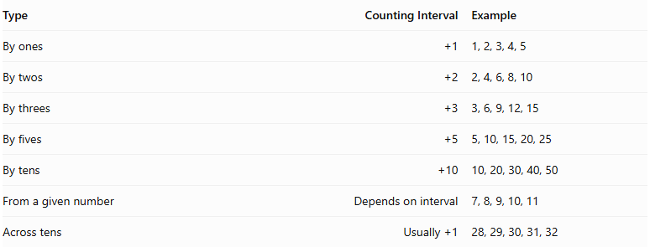
Type | Counting Interval | Example
By ones | $$+1$$ | 1, 2, 3, 4, 5
By twos | $$+2$$ | 2, 4, 6, 8, 10
By threes | $$+3$$ | 3, 6, 9, 12, 15
By fives | $$+5$$ | 5, 10, 15, 20, 25
By tens | $$+10$$ | 10, 20, 30, 40, 50
From a given number | Depends on interval | 7, 8, 9, 10, 11
Across tens | $$Usually+1$$ | 28, 29, 30, 31, 32

Classification in Number Operations
# Source: AI Source: Provided by: [Data Path: Persons Table -> ID Column: 1, Name_En Column: Motasem Essam] -> From: [ChatGPT] on [7/11/2026]
Main Category: Number Operations
Topic: Types of Counting
Type: Forward Counting
Main Subtypes:
- Forward Counting by Ones
- Forward Counting by Twos
- Forward Counting by Threes
- Forward Counting by Fives
- Forward Counting by Tens
- Forward Counting from a Given Number
- Forward Counting Across Tens

Key Points
# Source: AI Source: Provided by: [Data Path: Persons Table -> ID Column: 1, Name_En Column: Motasem Essam] -> From: [ChatGPT] on [7/11/2026]
Forward counting follows ascending numerical order.
It can begin from any specified starting number.
Counting intervals determine how much the number increases each time.
Forward counting by ones is the foundation of ordinary counting.
Skip counting by twos, threes, fives, and tens helps prepare learners for multiplication.
Crossing a multiple of ten does not interrupt the counting sequence.

Conclusion
# Source: AI Source: Provided by: [Data Path: Persons Table -> ID Column: 1, Name_En Column: Motasem Essam] -> From: [ChatGPT] on [7/11/2026]
Forward counting is a fundamental number operation that develops an understanding of numerical order and progression. It includes counting by ones and larger intervals, starting from different numbers, and continuing across tens. These skills provide a foundation for addition, subtraction, multiplication, and more advanced numerical patterns.

2. Backward Counting
# Source: AI Source: Provided by: [Data Path: Persons Table -> ID Column: 1, Name_En Column: Motasem Essam] -> From: [ChatGPT] on [7/11/2026]
Counting from a larger number to a smaller number.
Example:
10,9,8,7,6,5,…

Definition
# Source: AI Source: Provided by: [Data Path: Persons Table -> ID Column: 1, Name_En Column: Motasem Essam] -> From: [ChatGPT] on [7/11/2026]
Backward Counting is the process of counting numbers in descending order, starting from a given number and moving toward smaller numbers according to a specified counting sequence or decrement.
It is a fundamental counting skill that helps learners understand numerical order, recognize decreasing patterns, determine the preceding number, and develop the foundation for subtraction and other arithmetic operations.
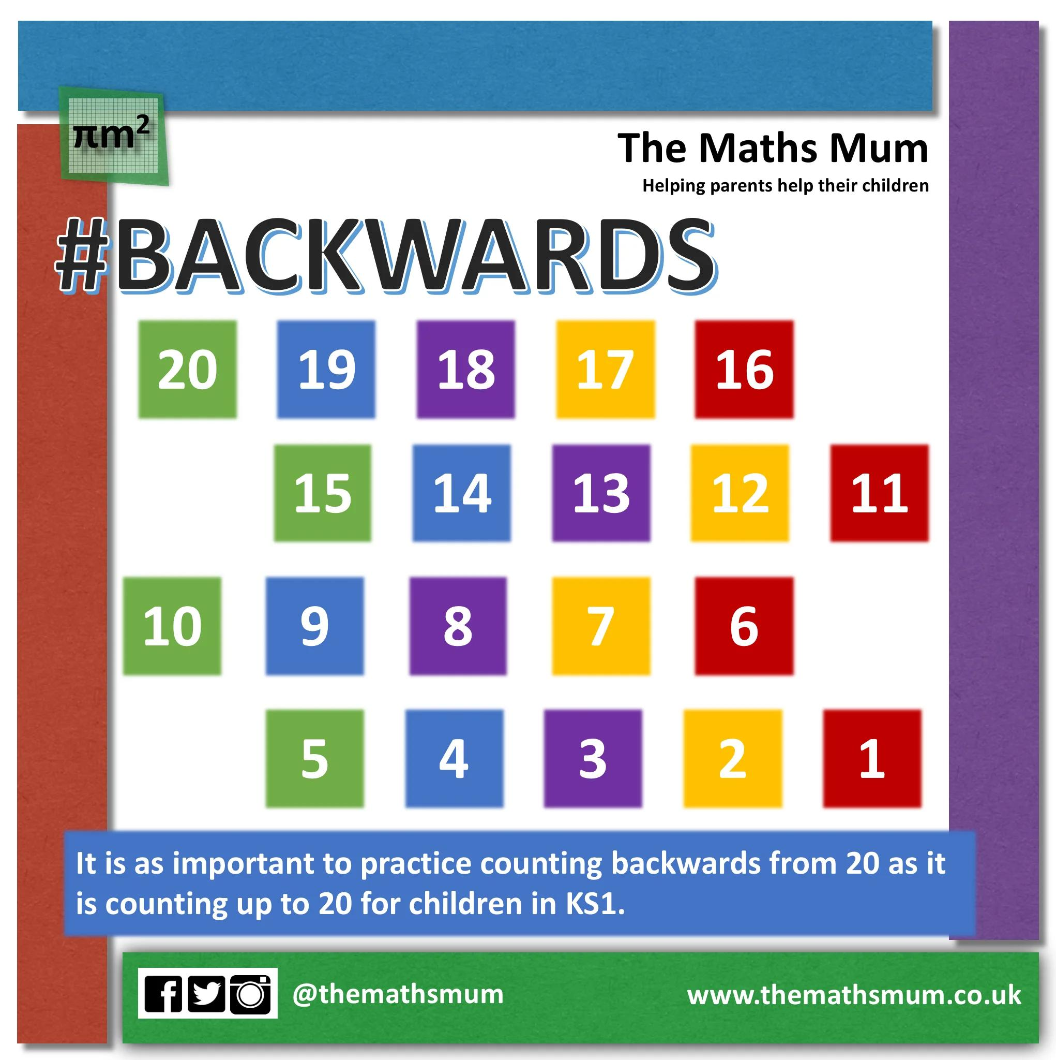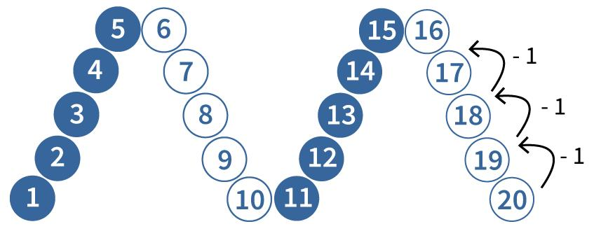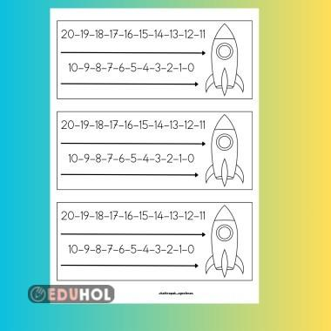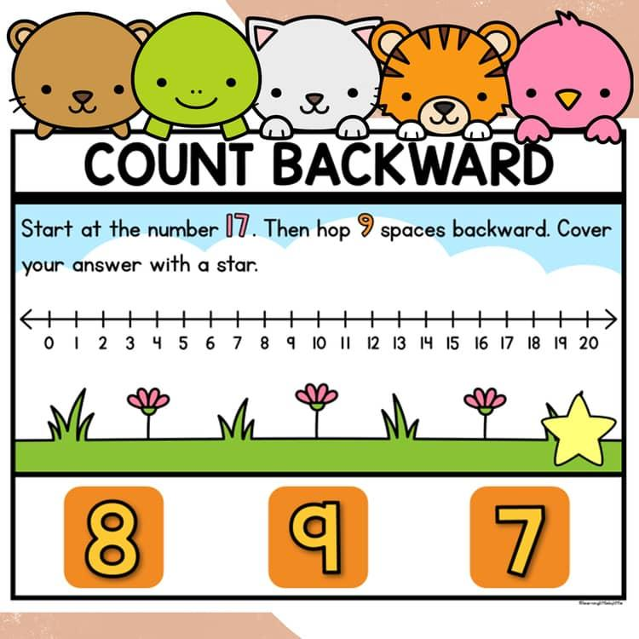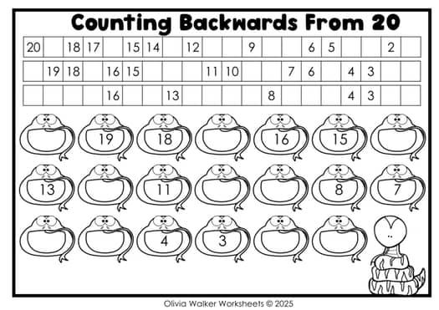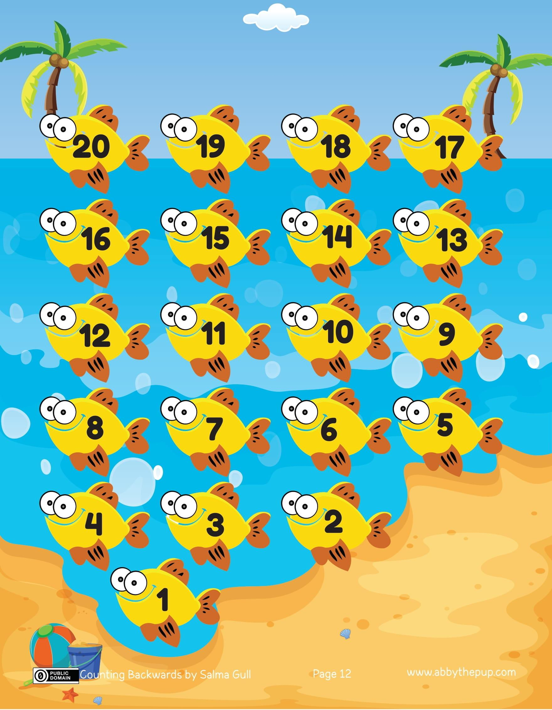

Simple Definition
# Source: AI Source: Provided by: [Data Path: Persons Table -> ID Column: 1, Name_En Column: Motasem Essam] -> From: [ChatGPT] on [7/11/2026]
Backward counting means saying or writing numbers from a larger number to a smaller number in the correct order.
Example:
10, 9, 8, 7, 6, 5, 4, 3, 2, 1
Each number is smaller than the number immediately before it.

Main Characteristics
# Source: AI Source: Provided by: [Data Path: Persons Table -> ID Column: 1, Name_En Column: Motasem Essam] -> From: [ChatGPT] on [7/11/2026]
- Descending Order: Numbers decrease as counting progresses.
- Starting Number: Counting can begin at any specified number.
- Counting Direction: The sequence moves toward smaller numbers.
- Consistent Decrement: Each next number follows the specified counting interval.
- Number Recognition: It strengthens recognition of numerical order in reverse.
- Pattern Recognition: It helps learners identify decreasing numerical sequences.
- Subtraction Foundation: It supports understanding subtraction as moving backward along a number line.

Types of Backward Counting

Backward Counting by Ones
# Source: AI Source: Provided by: [Data Path: Persons Table -> ID Column: 1, Name_En Column: Motasem Essam] -> From: [ChatGPT] on [7/11/2026]
Counting backward by ones means decreasing the current number by exactly one each time.
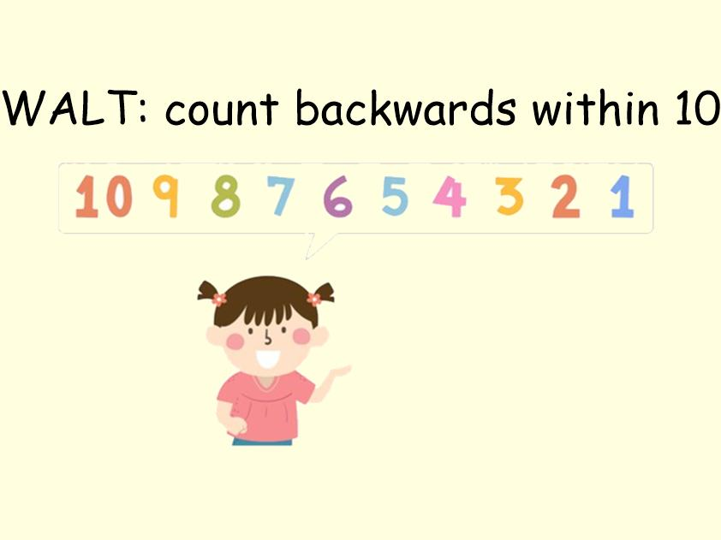
Example:
10, 9, 8, 7, 6, 5, 4, 3, 2, 1
Starting from 15:
15, 14, 13, 12, 11, 10, 9
Key Point: Each next number is obtained by subtracting 1.

Backward Counting by Twos
# Source: AI Source: Provided by: [Data Path: Persons Table -> ID Column: 1, Name_En Column: Motasem Essam] -> From: [ChatGPT] on [7/11/2026]
Counting backward by twos means decreasing the current number by 2 each time.
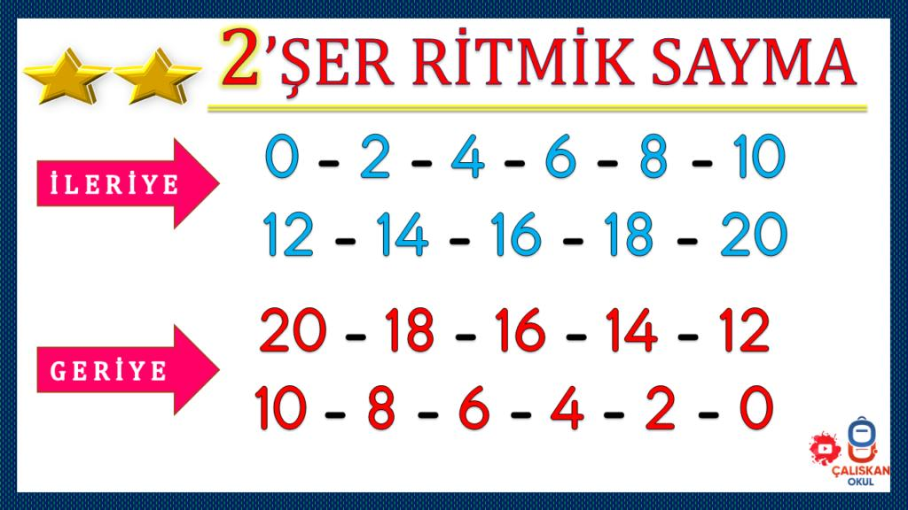
Example:
20, 18, 16, 14, 12, 10, 8, 6, 4, 2
Starting from 25:
25, 23, 21, 19, 17, 15
Key Point: Each next number is obtained by subtracting 2.

Backward Counting by Threes
# Source: AI Source: Provided by: [Data Path: Persons Table -> ID Column: 1, Name_En Column: Motasem Essam] -> From: [ChatGPT] on [7/11/2026]
Counting backward by threes means decreasing the current number by 3 each time.
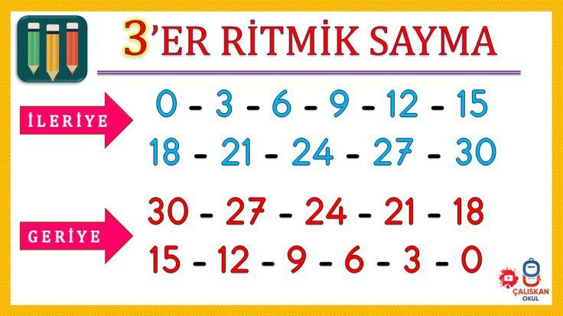
Example:
30, 27, 24, 21, 18, 15, 12, 9, 6, 3
Starting from 28:
28, 25, 22, 19, 16, 13
Key Point: Each next number is obtained by subtracting 3.

Backward Counting by Fives
# Source: AI Source: Provided by: [Data Path: Persons Table -> ID Column: 1, Name_En Column: Motasem Essam] -> From: [ChatGPT] on [7/11/2026]
Counting backward by fives means decreasing the current number by 5 each time.
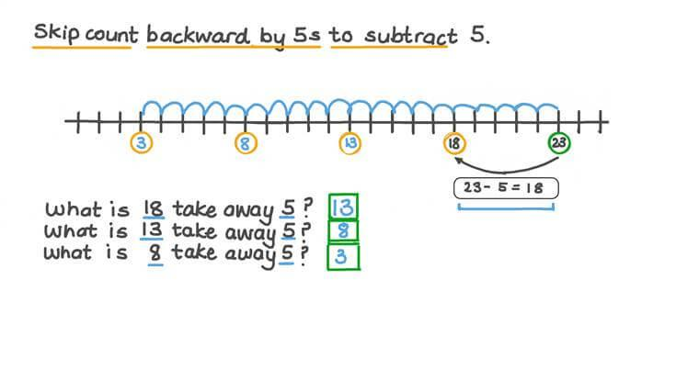
Example:
50, 45, 40, 35, 30, 25, 20, 15, 10, 5
Starting from 65:
65, 60, 55, 50, 45, 40
Key Point: Each next number is obtained by subtracting 5.

Backward Counting by Tens
# Source: AI Source: Provided by: [Data Path: Persons Table -> ID Column: 1, Name_En Column: Motasem Essam] -> From: [ChatGPT] on [7/11/2026]
Counting backward by tens means decreasing the current number by 10 each time.
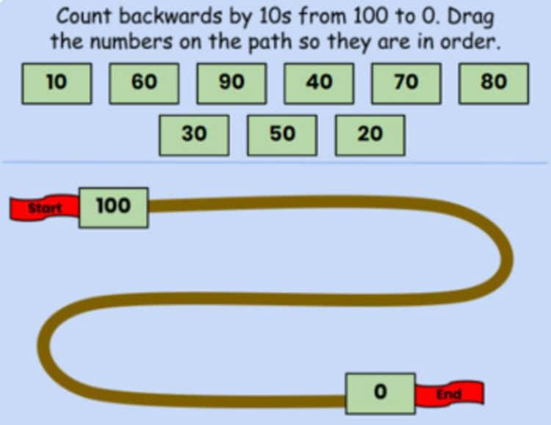
Example:
100, 90, 80, 70, 60, 50, 40, 30, 20, 10
Starting from 85:
85, 75, 65, 55, 45, 35
Key Point: Each next number is obtained by subtracting 10.

Backward Counting from a Given Number
# Source: AI Source: Provided by: [Data Path: Persons Table -> ID Column: 1, Name_En Column: Motasem Essam] -> From: [ChatGPT] on [7/11/2026]
This type begins with a specified starting number rather than necessarily beginning at 10 or another standard counting point. Counting then continues toward smaller numbers using the selected interval.
Example:
Starting from 17 and counting backward by ones:
17, 16, 15, 14, 13, 12
Starting from 30 and counting backward by twos:
30, 28, 26, 24, 22, 20
Key Point: The starting number can change without changing the backward direction.

Backward Counting Across Tens
# Source: AI Source: Provided by: [Data Path: Persons Table -> ID Column: 1, Name_En Column: Motasem Essam] -> From: [ChatGPT] on [7/11/2026]
This type focuses on continuing the counting sequence when moving from one group of ten to the preceding group of ten.
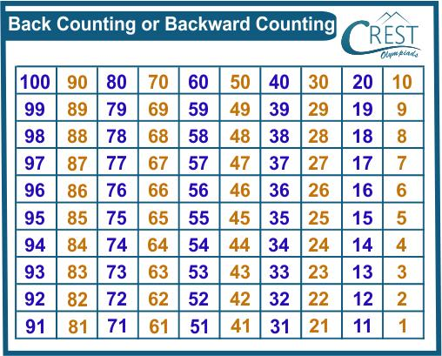
Example:
42, 41, 40, 39, 38, 37
Another example:
31, 30, 29, 28, 27, 26
Key Point: Counting continues normally when the ones digit changes from 0 to 9 and the tens digit decreases.

Comparison of Backward Counting Types
# Source: AI Source: Provided by: [Data Path: Persons Table -> ID Column: 1, Name_En Column: Motasem Essam] -> From: [ChatGPT] on [7/11/2026]
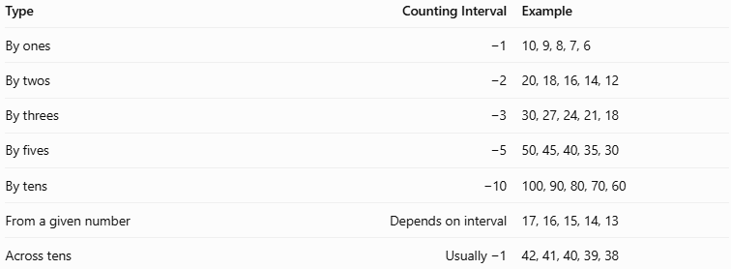
Type | Counting Interval | Example
By ones | −1 | 10, 9, 8, 7, 6
By twos | −2 | 20, 18, 16, 14, 12
By threes | −3 | 30, 27, 24, 21, 18
By fives | −5 | 50, 45, 40, 35, 30
By tens | −10 | 100, 90, 80, 70, 60
From a given number | Depends on interval | 17, 16, 15, 14, 13
Across tens | Usually −1 | 42, 41, 40, 39, 38

Classification in Number Operations
# Source: AI Source: Provided by: [Data Path: Persons Table -> ID Column: 1, Name_En Column: Motasem Essam] -> From: [ChatGPT] on [7/11/2026]
Main Category: Number Operations
Topic: Types of Counting
Type: Backward Counting
Main Subtypes:
- Backward Counting by Ones
- Backward Counting by Twos
- Backward Counting by Threes
- Backward Counting by Fives
- Backward Counting by Tens
- Backward Counting from a Given Number
- Backward Counting Across Tens

Key Points
# Source: AI Source: Provided by: [Data Path: Persons Table -> ID Column: 1, Name_En Column: Motasem Essam] -> From: [ChatGPT] on [7/11/2026]
Backward counting follows descending numerical order.
It can begin from any specified starting number.
Counting intervals determine how much the number decreases each time.
Backward counting by ones is the foundation of ordinary reverse counting.
Skip counting backward by twos, threes, fives, and tens helps develop subtraction skills.
Crossing a multiple of ten does not interrupt the counting sequence.

Conclusion
# Source: AI Source: Provided by: [Data Path: Persons Table -> ID Column: 1, Name_En Column: Motasem Essam] -> From: [ChatGPT] on [7/11/2026]
Backward counting is a fundamental number operation that develops an understanding of numerical order and decreasing patterns. It includes counting backward by ones and larger intervals, starting from different numbers, and continuing across tens. These skills provide a foundation for subtraction, numerical comparison, and more advanced arithmetic operations.

3. Skip Counting
# Source: AI Source: Provided by: [Data Path: Persons Table -> ID Column: 1, Name_En Column: Motasem Essam] -> From: [ChatGPT] on [7/11/2026]
Counting by numbers other than 1.
Examples:
By 2:
2,4,6,8,10,…
By 5:
5,10,15,20,…
By 10:
10,20,30,40,…

Definition
# Source: AI Source: Provided by: [Data Path: Persons Table -> ID Column: 1, Name_En Column: Motasem Essam] -> From: [ChatGPT] on [7/25/2026]
Skip Counting is the process of counting forward or backward by a fixed number greater than one, rather than counting by ones. Each number in the sequence is obtained by repeatedly adding or subtracting the same interval.
Skip counting helps learners recognize numerical patterns, understand multiplication and division, and calculate quantities more efficiently.
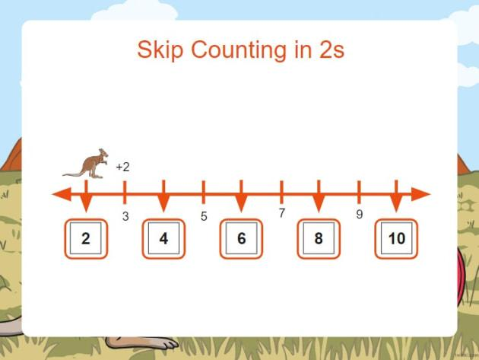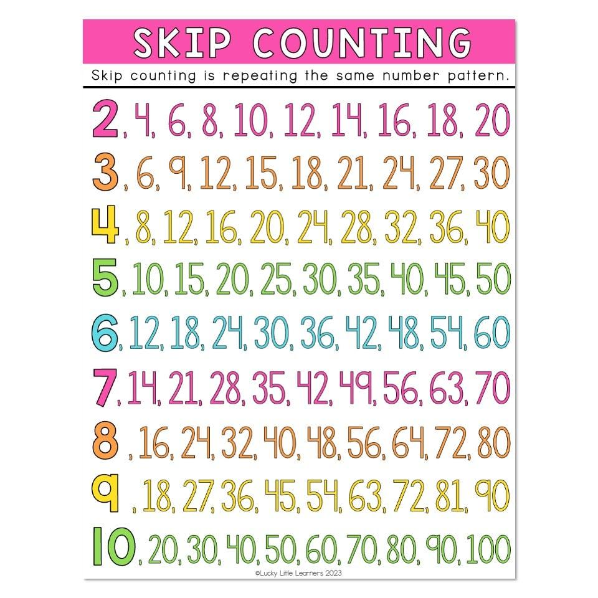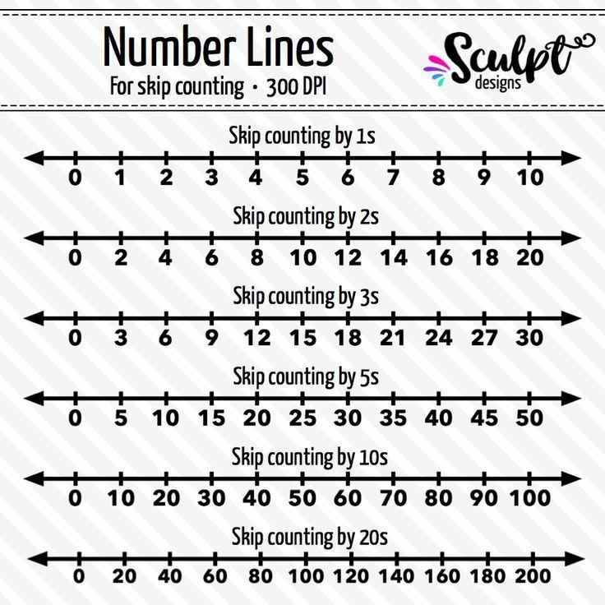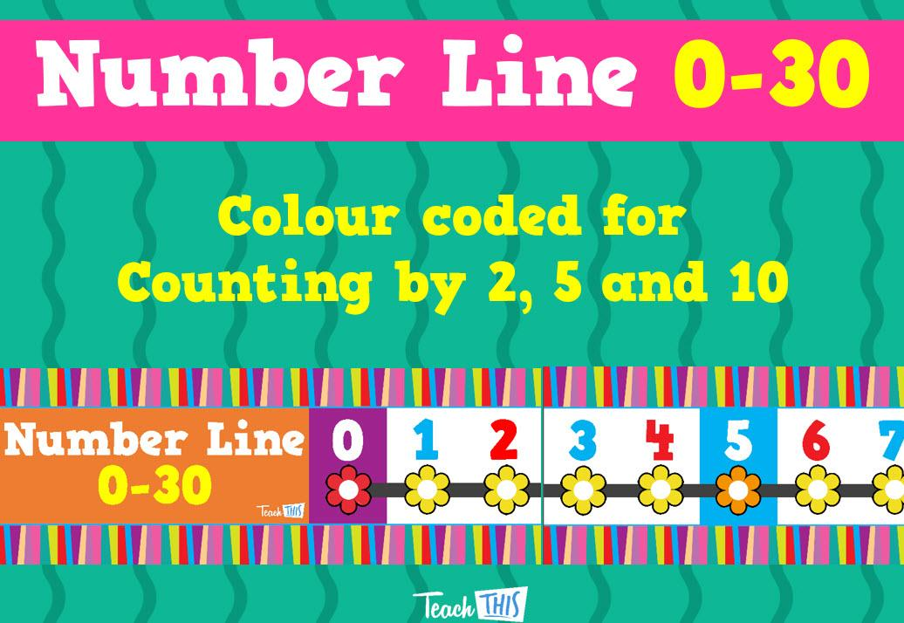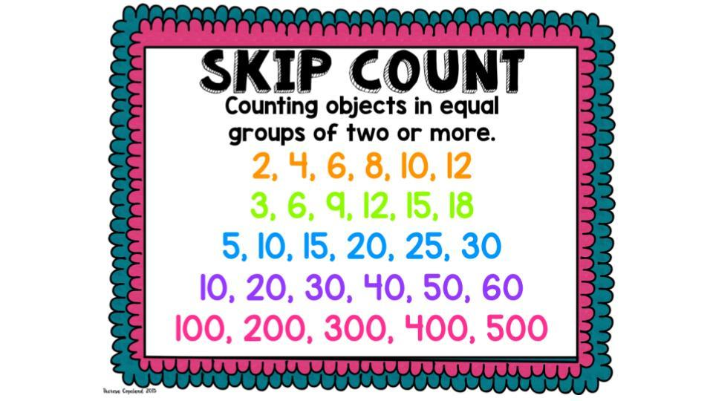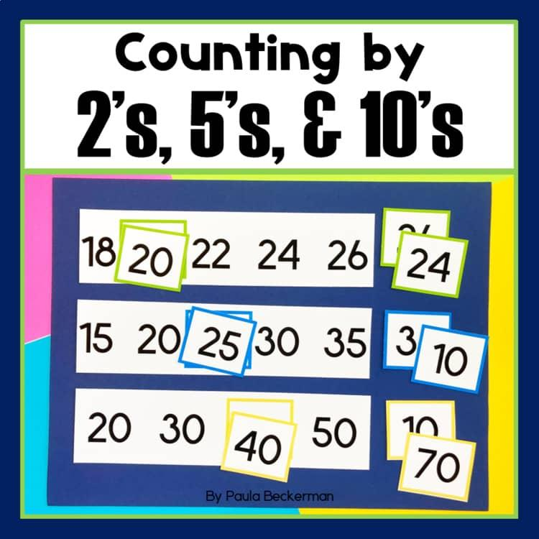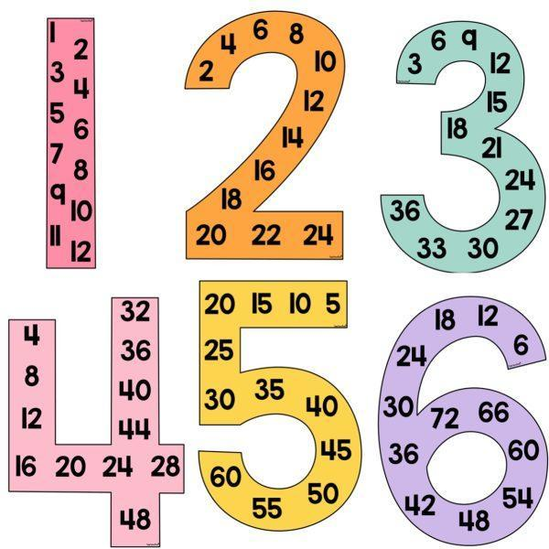

Simple Definition
# Source: AI Source: Provided by: [Data Path: Persons Table -> ID Column: 1, Name_En Column: Motasem Essam] -> From: [ChatGPT] on [7/25/2026]
Skip counting means moving through numbers using equal jumps.
Example – Counting forward by fives:
5, 10, 15, 20, 25, 30
Each number increases by 5.
Example – Counting backward by twos:
20, 18, 16, 14, 12, 10
Each number decreases by 2.

Main Characteristics
# Source: AI Source: Provided by: [Data Path: Persons Table -> ID Column: 1, Name_En Column: Motasem Essam] -> From: [ChatGPT] on [7/25/2026]
- Fixed Interval: Each counting step uses the same numerical difference.
- Repeated Addition: Forward skip counting adds the selected interval.
- Repeated Subtraction: Backward skip counting subtracts the selected interval.
- Number Patterns: It creates predictable sequences.
- Multiplication Foundation: Forward skip counting connects repeated addition with multiplication.
- Division Foundation: Backward skip counting helps identify how many equal groups can be removed.
- Efficiency: It allows larger quantities to be counted more quickly than counting by ones.

Types of Skip Counting

Skip Counting by Twos
# Source: AI Source: Provided by: [Data Path: Persons Table -> ID Column: 1, Name_En Column: Motasem Essam] -> From: [ChatGPT] on [7/25/2026]
Skip counting by twos means increasing or decreasing the current number by 2 each time.
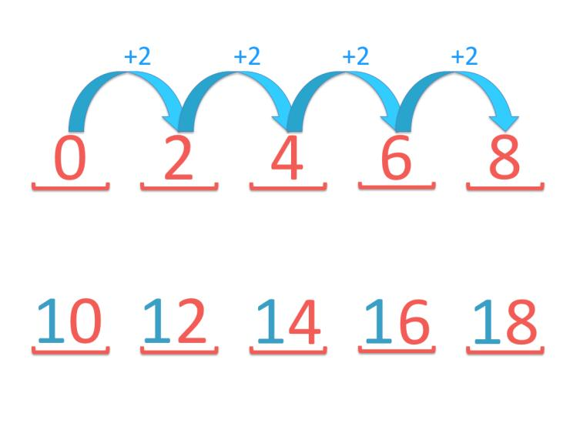
Forward Example:
2, 4, 6, 8, 10, 12, 14, 16, 18, 20
Backward Example:
20, 18, 16, 14, 12, 10, 8, 6, 4, 2
Key Point: Each step changes the number by 2.

Skip Counting by Threes
# Source: AI Source: Provided by: [Data Path: Persons Table -> ID Column: 1, Name_En Column: Motasem Essam] -> From: [ChatGPT] on [7/25/2026]
Skip counting by threes means increasing or decreasing the current number by 3 each time.
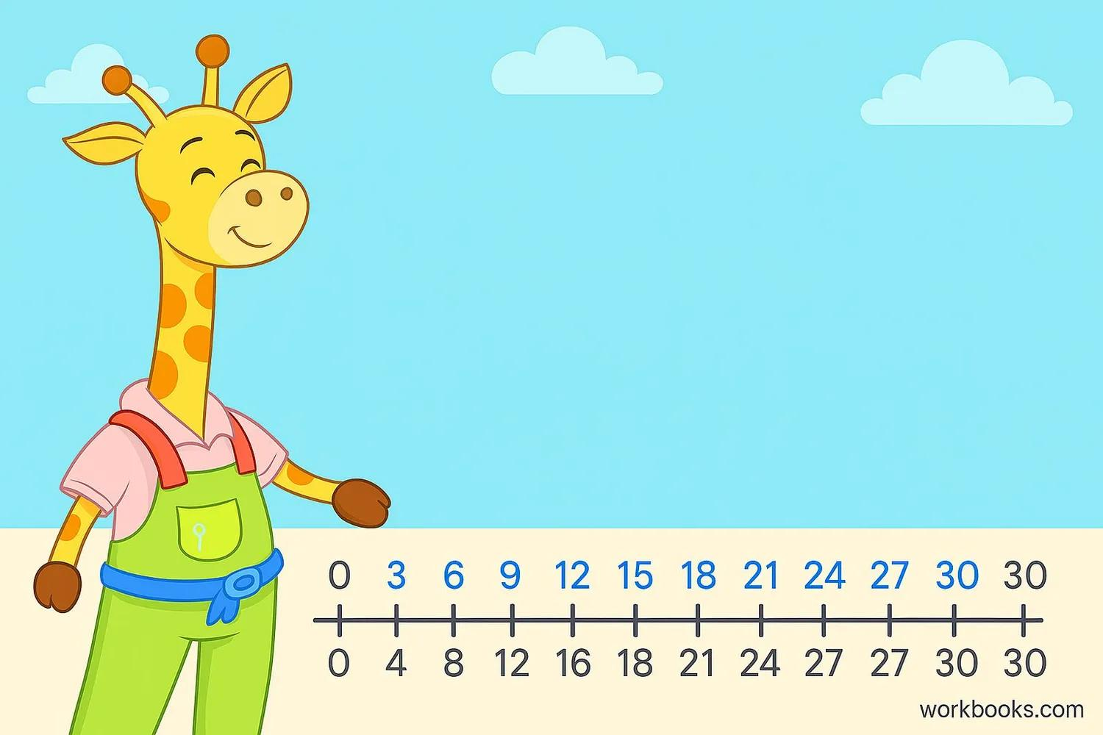
Forward Example:
3, 6, 9, 12, 15, 18, 21, 24, 27, 30
Backward Example:
30, 27, 24, 21, 18, 15, 12, 9, 6, 3
Key Point: Each step changes the number by 3.

Skip Counting by Fours
# Source: AI Source: Provided by: [Data Path: Persons Table -> ID Column: 1, Name_En Column: Motasem Essam] -> From: [ChatGPT] on [7/25/2026]
Skip counting by fours means increasing or decreasing the current number by 4 each time.
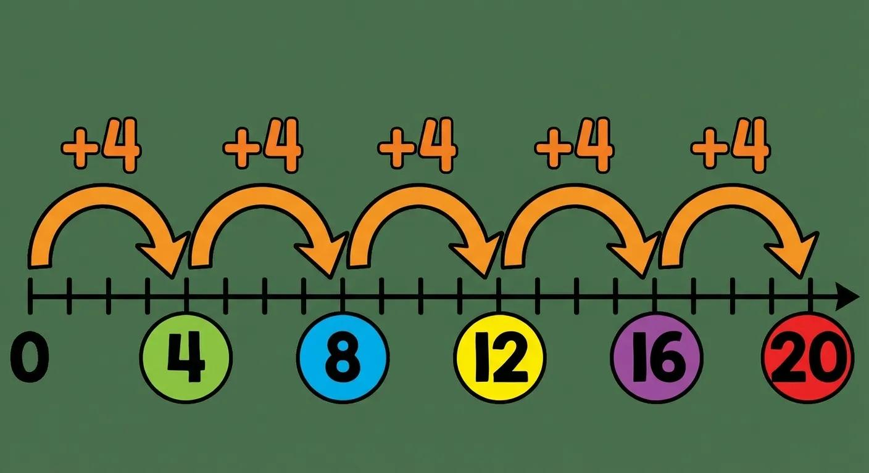
Forward Example:
4, 8, 12, 16, 20, 24, 28, 32, 36, 40
Backward Example:
40, 36, 32, 28, 24, 20, 16, 12, 8, 4
Key Point: Each step changes the number by 4.

Skip Counting by Fives
# Source: AI Source: Provided by: [Data Path: Persons Table -> ID Column: 1, Name_En Column: Motasem Essam] -> From: [ChatGPT] on [7/25/2026]
Skip counting by fives means increasing or decreasing the current number by 5 each time.
Forward Example:
5, 10, 15, 20, 25, 30, 35, 40, 45, 50
Backward Example:
50, 45, 40, 35, 30, 25, 20, 15, 10, 5
Key Point: Each step changes the number by 5.

Skip Counting by Sixes
# Source: AI Source: Provided by: [Data Path: Persons Table -> ID Column: 1, Name_En Column: Motasem Essam] -> From: [ChatGPT] on [7/25/2026]
Skip counting by sixes means increasing or decreasing the current number by 6 each time.
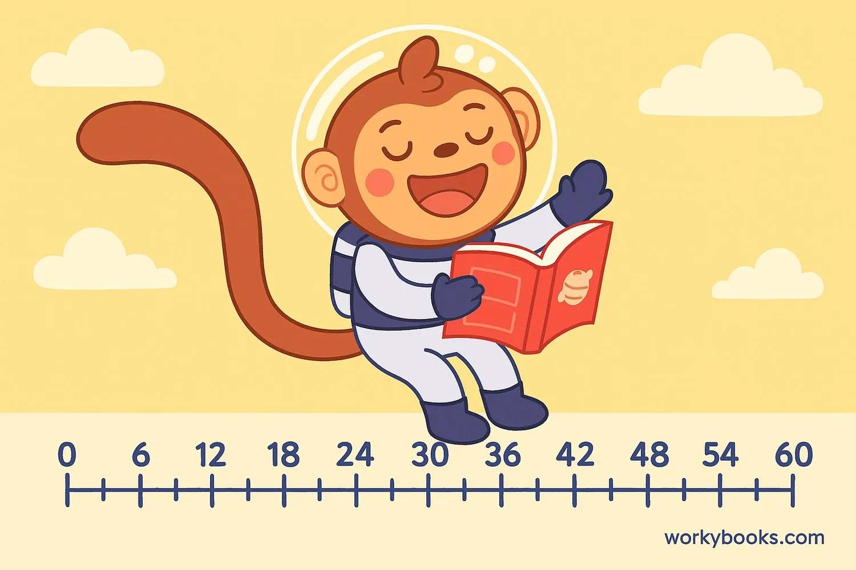
Forward Example:
6, 12, 18, 24, 30, 36, 42, 48, 54, 60
Backward Example:
60, 54, 48, 42, 36, 30, 24, 18, 12, 6
Key Point: Each step changes the number by 6.

Skip Counting by Sevens
# Source: AI Source: Provided by: [Data Path: Persons Table -> ID Column: 1, Name_En Column: Motasem Essam] -> From: [ChatGPT] on [7/25/2026]
Skip counting by sevens means increasing or decreasing the current number by 7 each time.
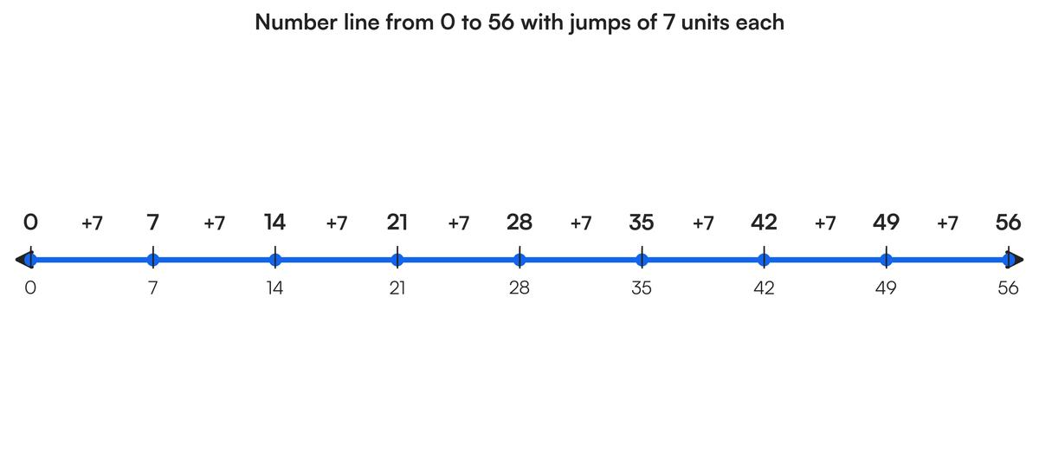
Forward Example:
7, 14, 21, 28, 35, 42, 49, 56, 63, 70
Backward Example:
70, 63, 56, 49, 42, 35, 28, 21, 14, 7
Key Point: Each step changes the number by 7.

Skip Counting by Eights
# Source: AI Source: Provided by: [Data Path: Persons Table -> ID Column: 1, Name_En Column: Motasem Essam] -> From: [ChatGPT] on [7/25/2026]
Skip counting by eights means increasing or decreasing the current number by 8 each time.
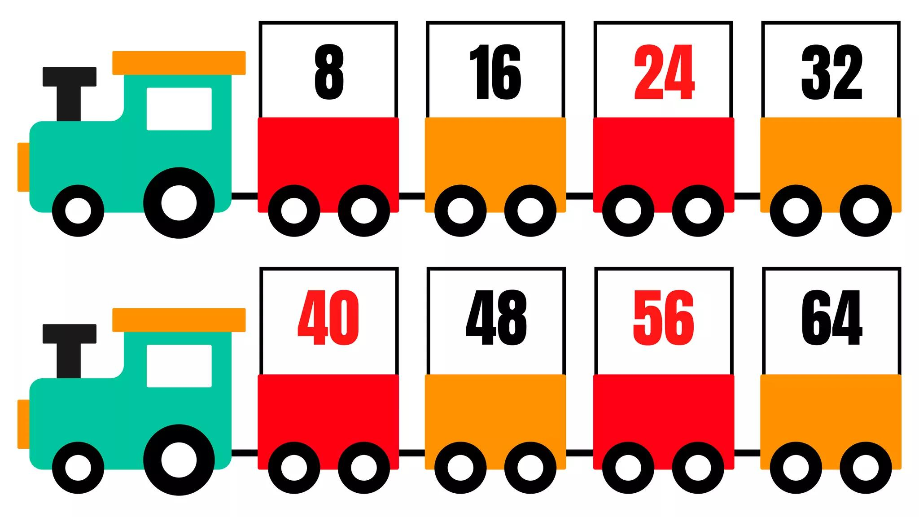
Forward Example:
8, 16, 24, 32, 40, 48, 56, 64, 72, 80
Backward Example:
80, 72, 64, 56, 48, 40, 32, 24, 16, 8
Key Point: Each step changes the number by 8.

Skip Counting by Nines
# Source: AI Source: Provided by: [Data Path: Persons Table -> ID Column: 1, Name_En Column: Motasem Essam] -> From: [ChatGPT] on [7/25/2026]
Skip counting by nines means increasing or decreasing the current number by 9 each time.
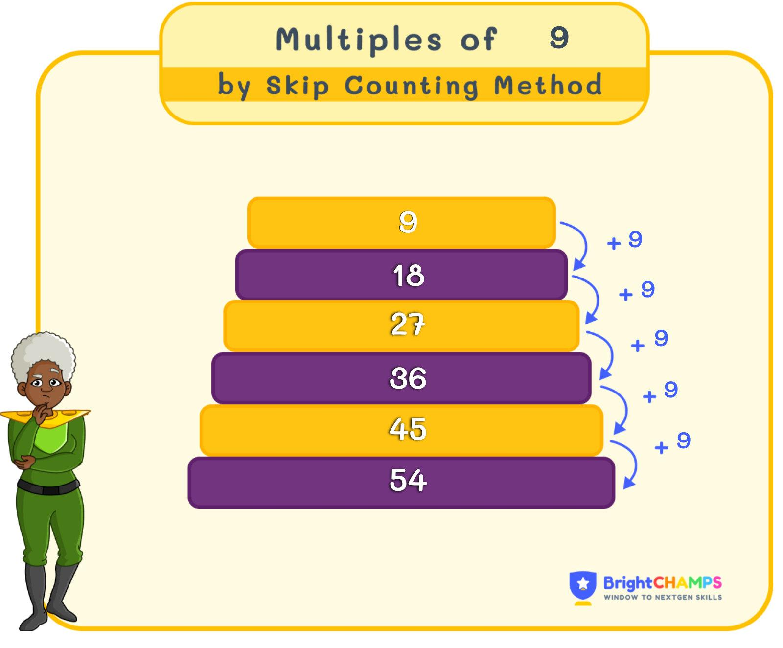
Forward Example:
9, 18, 27, 36, 45, 54, 63, 72, 81, 90
Backward Example:
90, 81, 72, 63, 54, 45, 36, 27, 18, 9
Key Point: Each step changes the number by 9.

Skip Counting by Tens
# Source: AI Source: Provided by: [Data Path: Persons Table -> ID Column: 1, Name_En Column: Motasem Essam] -> From: [ChatGPT] on [7/25/2026]
Skip counting by tens means increasing or decreasing the current number by 10 each time.
Forward Example:
10, 20, 30, 40, 50, 60, 70, 80, 90, 100
Backward Example:
100, 90, 80, 70, 60, 50, 40, 30, 20, 10
Key Point: Each step changes the number by 10.

Skip Counting by Hundreds
# Source: AI Source: Provided by: [Data Path: Persons Table -> ID Column: 1, Name_En Column: Motasem Essam] -> From: [ChatGPT] on [7/25/2026]
Skip counting by hundreds means increasing or decreasing the current number by 100 each time.
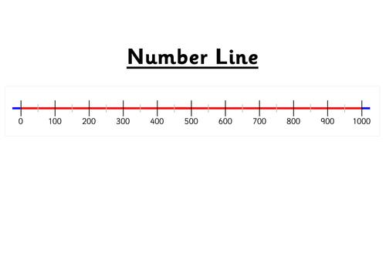
Forward Example:
100, 200, 300, 400, 500, 600, 700, 800, 900, 1000
Backward Example:
1000, 900, 800, 700, 600, 500, 400, 300, 200, 100
Key Point: Each step changes the number by 100.

Skip Counting by a Given Interval
# Source: AI Source: Provided by: [Data Path: Persons Table -> ID Column: 1, Name_En Column: Motasem Essam] -> From: [ChatGPT] on [7/25/2026]
This type begins from a specified number and continues by repeatedly adding or subtracting a chosen interval. The starting number does not have to be a multiple of the interval.
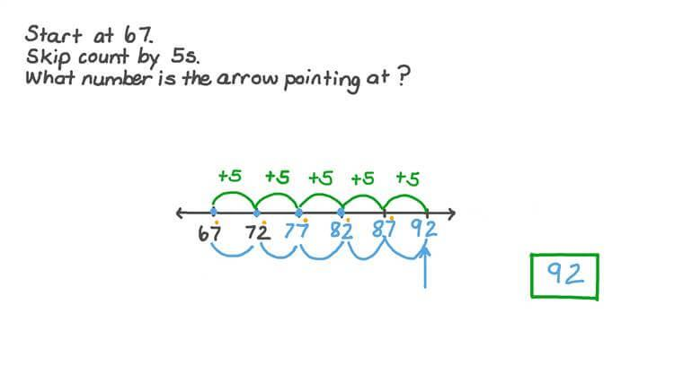
Forward Example:
Starting from 7 and counting by 5:
7, 12, 17, 22, 27, 32
Backward Example:
Starting from 32 and counting backward by 5:
32, 27, 22, 17, 12, 7
Key Point: The interval remains constant even when the starting number is not a multiple of it.

Comparison of Skip Counting Types
# Source: AI Source: Provided by: [Data Path: Persons Table -> ID Column: 1, Name_En Column: Motasem Essam] -> From: [ChatGPT] on [7/25/2026]
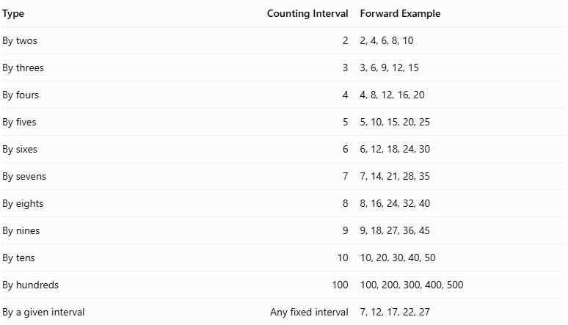
Type | Counting Interval | Forward Example
By twos | 2 | 2, 4, 6, 8, 10
By threes | 3 | 3, 6, 9, 12, 15
By fours | 4 | 4, 8, 12, 16, 20
By fives | 5 | 5, 10, 15, 20, 25
By sixes | 6 | 6, 12, 18, 24, 30
By sevens | 7 | 7, 14, 21, 28, 35
By eights | 8 | 8, 16, 24, 32, 40
By nines | 9 | 9, 18, 27, 36, 45
By tens | 10 | 10, 20, 30, 40, 50
By hundreds | 100 | 100, 200, 300, 400, 500
By a given interval | Any fixed interval | 7, 12, 17, 22, 27

Classification in Number Operations
# Source: AI Source: Provided by: [Data Path: Persons Table -> ID Column: 1, Name_En Column: Motasem Essam] -> From: [ChatGPT] on [7/25/2026]
Main Category: Number Operations
Topic: Types of Counting
Type: Skip Counting
Main Subtypes:
- Skip Counting by Twos
- Skip Counting by Threes
- Skip Counting by Fours
- Skip Counting by Fives
- Skip Counting by Sixes
- Skip Counting by Sevens
- Skip Counting by Eights
- Skip Counting by Nines
- Skip Counting by Tens
- Skip Counting by Hundreds
- Skip Counting by a Given Interval

Key Points
# Source: AI Source: Provided by: [Data Path: Persons Table -> ID Column: 1, Name_En Column: Motasem Essam] -> From: [ChatGPT] on [7/25/2026]
Skip counting uses a fixed interval greater than one.
It can proceed forward or backward.
The starting number can be any suitable number.
Each step follows the same addition or subtraction rule.
Skip counting by a number helps learners understand its multiples.
It supports multiplication, division, repeated addition, and numerical pattern recognition.

Conclusion
# Source: AI Source: Provided by: [Data Path: Persons Table -> ID Column: 1, Name_En Column: Motasem Essam] -> From: [ChatGPT] on [7/25/2026]
Skip counting is an efficient counting method in which numbers increase or decrease by a fixed interval. It includes counting by twos, threes, fours, fives, and other intervals, as well as counting from a specified starting number. It strengthens numerical pattern recognition and provides an important foundation for multiplication and division.

Examples
# Source: AI Source: Provided by: [Data Path: Persons Table -> ID Column: 1, Name_En Column: Motasem Essam] -> From: [ChatGPT] on [7/11/2026]
○ Example 1
Count the stars.
⭐⭐⭐⭐⭐
Count:
1, 2, 3, 4, 5
Answer:
There are 5 stars.

○ Example 2
Books on a shelf:
📚📚📚📚📚📚📚
Answer:
There are 7 books.

○ Illustration
Suppose a teacher asks:
"How many students are in the classroom?"
A student counts:
1, 2, 3, ..., 28
The answer is:
There are 28 students.

Counting Examples in Real Life
# Source: AI Source: Provided by: [Data Path: Persons Table -> ID Column: 1, Name_En Column: Motasem Essam] -> From: [ChatGPT] on [7/11/2026]
1. Counting Money
Counting coins or banknotes.

2. Attendance
Counting students in a classroom.

3. Shopping
Counting purchased items.

4. Sports
Counting goals, points, or players.

5. Inventory
Counting products in a warehouse.

6. Voting
Counting votes.

7. Manufacturing
Counting produced items.

8. Population
Counting people in a city or country.

Counting vs. Cardinal Numbers
# Source: AI Source: Provided by: [Data Path: Persons Table -> ID Column: 1, Name_En Column: Motasem Essam] -> From: [ChatGPT] on [7/11/2026]
Counting is the process.
A cardinal number is the result.
Example:
Count:
1, 2, 3, 4, 5
Final answer:
There are 5 objects.
The number 5 is the cardinal number.

Applications of Counting
# Source: AI Source: Provided by: [Data Path: Persons Table -> ID Column: 1, Name_En Column: Motasem Essam] -> From: [ChatGPT] on [7/11/2026]
Counting is used in:
- Arithmetic
- Statistics
- Probability
- Computer Science
- Inventory Management
- Banking
- Business
- Scientific Research
- Daily Life

Conclusion
# Source: AI Source: Provided by: [Data Path: Persons Table -> ID Column: 1, Name_En Column: Motasem Essam] -> From: [ChatGPT] on [7/11/2026]
Counting is the process of determining the number of objects in a collection by assigning one counting number to each object exactly once. It is one of the first arithmetic skills learned and serves as the foundation for understanding numbers, arithmetic operations, and more advanced mathematical concepts.

Summary Comparison
# Source: AI Source: Provided by: [Data Path: Persons Table -> ID Column: 1, Name_En Column: Motasem Essam] -> From: [ChatGPT] on [7/11/2026]
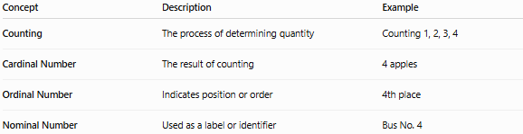
Concept | Description | Example
Counting | The process of determining quantity | Counting 1, 2, 3, 4
Cardinal Number | The result of counting | 4 apples
Ordinal Number | Indicates position or order | 4th place
Nominal Number | Used as a label or identifier | Bus No. 4
Memory Tip
Remember the sequence:
- Count the objects.
- The last number counted is the cardinal number.
- If you are describing position, use an ordinal number.
- If the number is only an identifier, it is a nominal number.
A simple phrase to remember is:
"Counting finds quantity."

